Project Title: Cultural Landscape

Team Member: Wesley Mao

**INTRODUCTION**

Urban planning is an important concept with the modern city. It affects how the city will grow and be developed. Neighborhood is one of the important concept for urban planning. Each neighborhood has its own characteristic [1, 2, 3]. By the definition in wiki, neighborhood is a community that were geographical localized within a larger city. It often brings people with the same culture background or life style together. In New York City, there are little Italy, Chinatown, Korea Town, Chelsea, etc. All these different neighborhoods have different cultures associated to them. They also have their own boundary. They do not overlap each other. However, if we take a closer look, the way people live and socialize is a fluid process. There is not a physical barrier between different neighborhoods to stop them from influencing each other. Therefore, the boundary of different neighborhood should be more porous and ambiguous. We can look at it from a different angle. If the area of the neighborhoods were defined by the different culture or lifestyle, we might have a different view and insight on the way we plan a city. We all know we can find the most Chinese food in a Chinese community, and vice versa. Therefore, I am making an assumption that I can map out the community with different culture background with the locations of the different cuisines. This cultural map of a city can help the urban planner to have a better idea on how the different culture were merging or segregating in a city. On a lighter and smaller contribution, it might be able to help us to find the most authentic food in conjunction with the highest review from yelp.

**DESIGN AND IMPLEMENTATION**

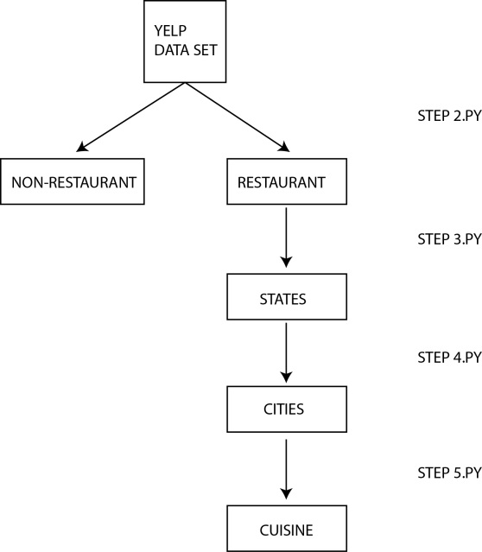In order to achieve the desire result, data wrangling and cleaning was performed to the yelp data set. The yelp data set has much more information that is not relevant to the project idea. At first, I used step1.py (/yelpP3/json/step1.py) to reformat the provided json file to be in “[]” and separated by “,”. Since I was only interested in the restaurants in difference city, I partitioned the data set into two different sets (/yelpP3/json/step2.py). One was restaurants and the other one was non-restaurants. This would give us a much smaller data set to work with. The next step is to partition the restaurant data set into different states and city (/yelpP3/json/step3.py and /yelpP3/json/step4.py). Once the data set are partitioned into different city, I performed some data transformations (/yelpP3/json/step5.py). Process flow is showed in Figure 1.

Figure 1 Partition Diagram

To make the JSON easier to read, I emptied out the “hours” and “attribute” information since they were irrelevant to the study. Next, in order to for me to visualize the data with D3 easier later, I changed the scale and shift the longitude and latitude information so I could map them onto a 700 x 1000 svg canvas. First I added an offset to both the longitude and latitude so the smallest one would always start at 10. Then divide 980 by the new maximum number. This would give us a multiplier. The last step is to multiply the number with the multiplier to get the correct numbers.

The next major step was to partition the different restaurants into different cuisines. First of all, the different color was set up for different cuisine for the ease of displaying later. Then I analyzed the “categories” field. Most of the data in the field have the cuisine type already. I just replaced it with the corresponding color. For the restaurant that did not have cuisine type in the field, I did an investigation on the content then replace it with the correct cuisine type. For example, if the data has “pizza” instead of “Italian”, I replaced the data with Italian. 35 different cuisines were found and used with this method.

After the dataset was clean and ready to be used, the data were imported into MongoDB for the web app to access. A MEAN stack was used to develop the web application. MEAN stack included mongodb, express JS, Anguler JS, and Node JS. The server was set up in Node JS with express framework. The client is in HTML5 with CSS3 and Angular JS framework. D3 was also incorporated to visualize the data on the web.

The web application is hosted with Heroku (http:// <http://secret-forest-9378.herokuapp.com/>). The service for mongodb is mongolab. After arriving the web page, you would be showed with the Peoria, AZ map as default. You can select a different city from the drop down menu located at the upper right hand corner. Once a city is selected, a query to the mongodb is sent. Then D3 will plot the map with the returned JSON data object. Currently, the database only has Peoria, Scottsdale, Mesa, Glendale and Phoenix from Arizona for demo purpose (Please use IE to view the Web App).

**RESULT**

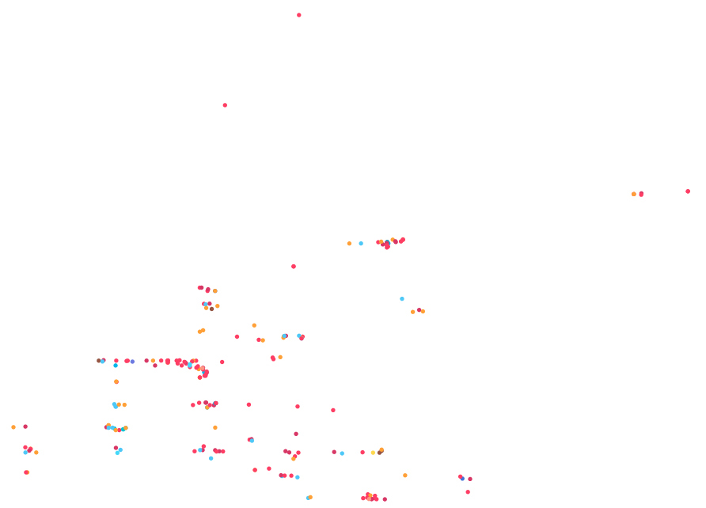Figure two shows the cuisine landscape of the Peoria, AZ. We can see that the city size can be considered a small size judging by the number restaurants. The central strip with the most concentration of the restaurants symbolized the area with the most vibrant social scene.

Figure 2 - Peoria, AZ

In Figure three, we can determine that there is a concentration of Asian restaurants in the blue zone which might symbolize an Asian neighborhood. The same idea can be apply to the orange (Italian) and merlot (Mexican) zone.

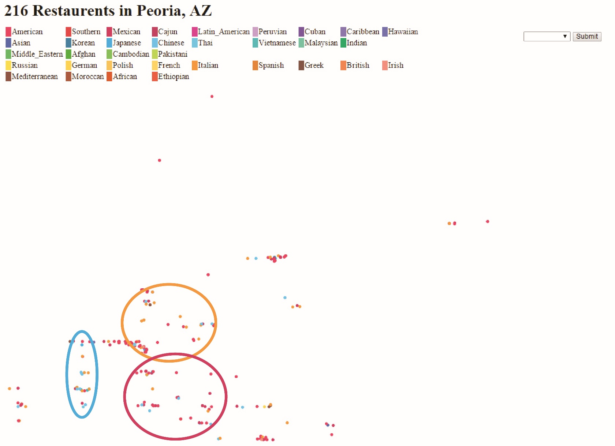

Figure 3 - Peoria zoning

Figure four shows the restaurants layout of Scottsdale, Arizona. We can also locate several pocket of concentration of main vibrant social area within the city. Also, the city can be categorized into a medium size city judging from the number of restaurants. Since the restaurants are much sparser beside the concentrated area, we also can make the assumption that it is a closer to a suburban city than a metropolitan. Now let us take a look at the Figure five. When we tried to analyze the culture and neighborhood of Scottsdale, we can see that layout of the different color dots are more spread out. However, we can find most of the Asian restaurants are located in the center compare to the outskirt of the city. Also, within that central zone, we can find small pockets of Mexican in it. On the other hand, Italian or European are mixed up together and spread out the city fairly evenly.

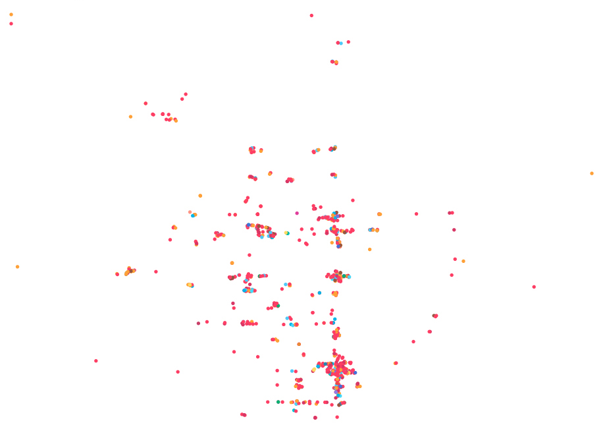

Figure 4 - Scottsdale, AZ

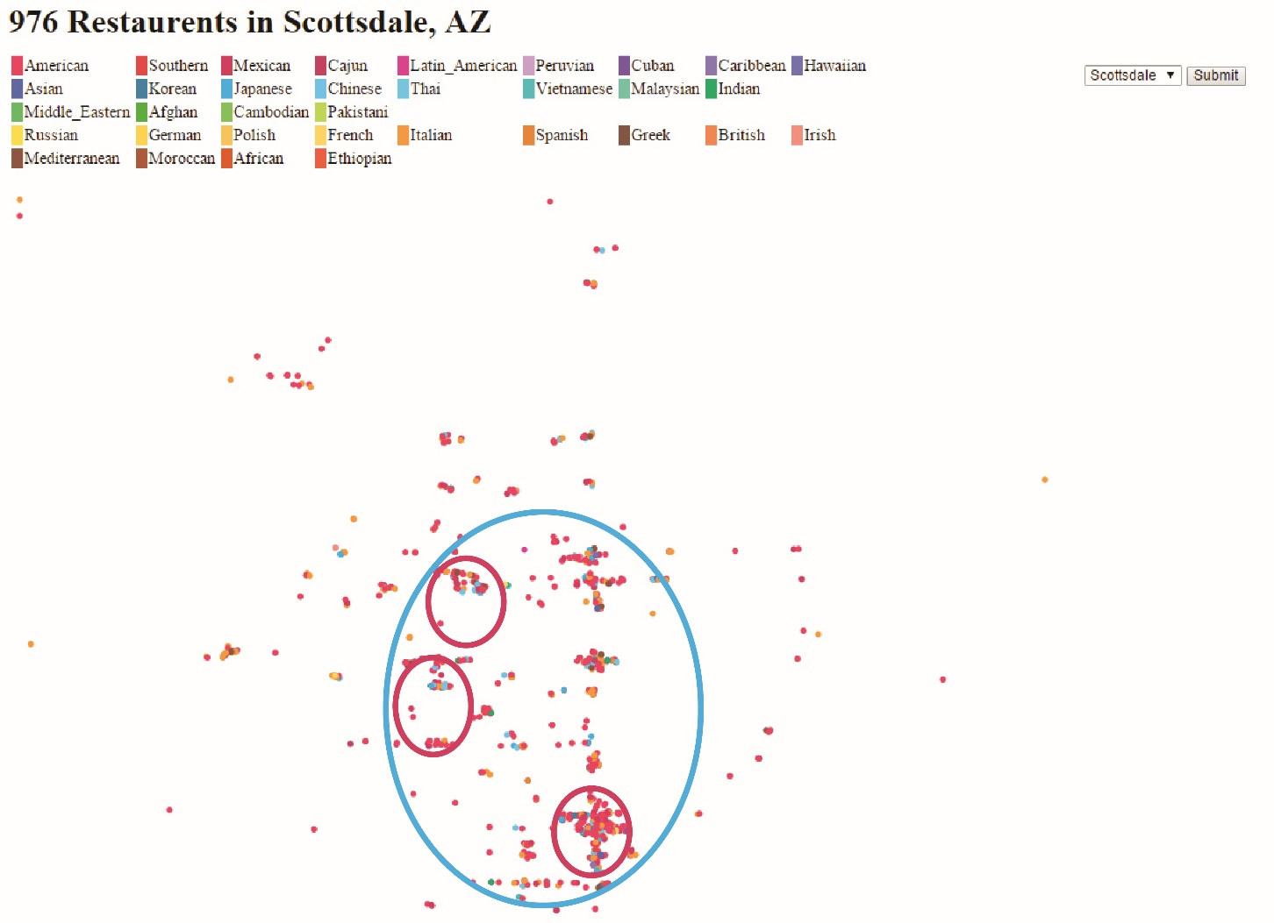

Figure 5 - Scottsdale Zoning

Last city we analyze is Phoenix, Arizona. First of all, judging from the layout and number of the restaurants, we can immediately tell Phoenix is a larger city than Peoria and Scottsdale. We also noticed the grid layout of the street in Phoenix right away. That tells us the city is planned on an orthogonal grid. We still can find an area with a concentration of the restaurants in the middle toward south part of the city. However, the restaurants are very evenly located throughout the city. This tell us the city itself is more concentrated and can be consider closer to a metropolitan. We can analyze it further as Figure 7 suggested. The boundary of different culture is less apparent in a metropolitan city like Phoenix. The Asian blue dots are evenly spread out across the city and the same with Italian, European, and Mexican. However, we can find little pockets of Middle Eastern located primary the north side of the city and just the north of the most popular area.

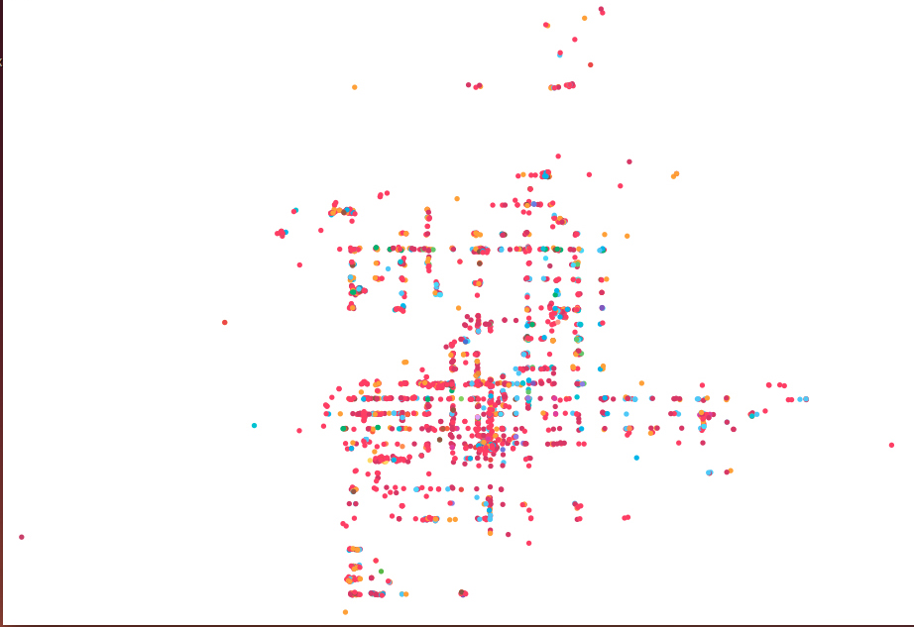

Figure 6 - Phoenix, AZ

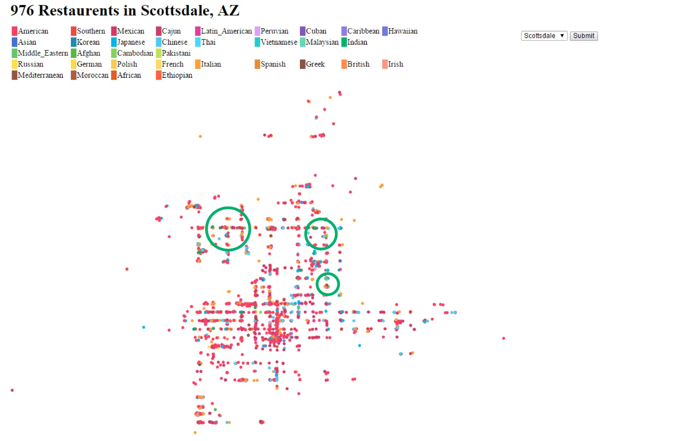

Figure 7 - Phoenix Zoning

**FUTURE WORK**

More data from different states can be loaded into the mongodb for the future works. Also, we could consider removing American cuisine if we only consider data from the United State. The reason is American cuisine in the state can be consider a default and unimportant compare to other cuisine and culture. We could also combine points from the same cuisine and within a very close distance. The combined point would also increase dimension in radius. This future work could give us an influence area of the different cuisines.

**CONCLUSION**

After studying the three different cities in Arizona, we can find the direct correlation between the city size and the number of restaurants. A city like Peoria with a population of 160,000 and a density of 865/sq mi. is a much smaller city with very few different cultures. Therefore, the pocket is more noticeable and easier to have segregation between different the different cultures [4]. As the city population and density starts to increase, the culture boundary starts to become porous and merging into each other, like Scottsdale (population of 230,000 and density of 1300/sq mi) [5]. We also can see this happen when comparing Scottsdale and Phoenix. Phoenix has a population of 1.5 million and a density of 2800/sq mi [6]. We can see the increase from our culture map very easily. We can also see the merging of different cultures become very apparent in the Phoenix diagram. The merging of different cultures is desired by urban planner. The merging of cultures makes people having a more open mind than the segregated cultures in small city. Ultimately, the barrier between the different cultural pockets needs to be broken whether simply by the growth of the city or by the strategic planning of urban planner. That is what would truly make a global city [1, 2, 3].

**REFERENCES**

[1] Hirschman, Charles. The use of Demography in Development Planning. Economic development and cultural change Vol. 29, No. 3, April 1981.

[2] <http://downtown-creator.net/2009/04/04/new-urbanism-vs-suburbanism/>

[3] <https://training.measureevaluation.org/non-certficate-courses/pap/lesson-2>

[4] <http://en.wikipedia.org/wiki/Peoria,_Arizona>

[5] <http://en.wikipedia.org/wiki/Scottsdale,_Arizona>

[6] <http://en.wikipedia.org/wiki/Phoenix,_Arizona>

**APPENDIX**

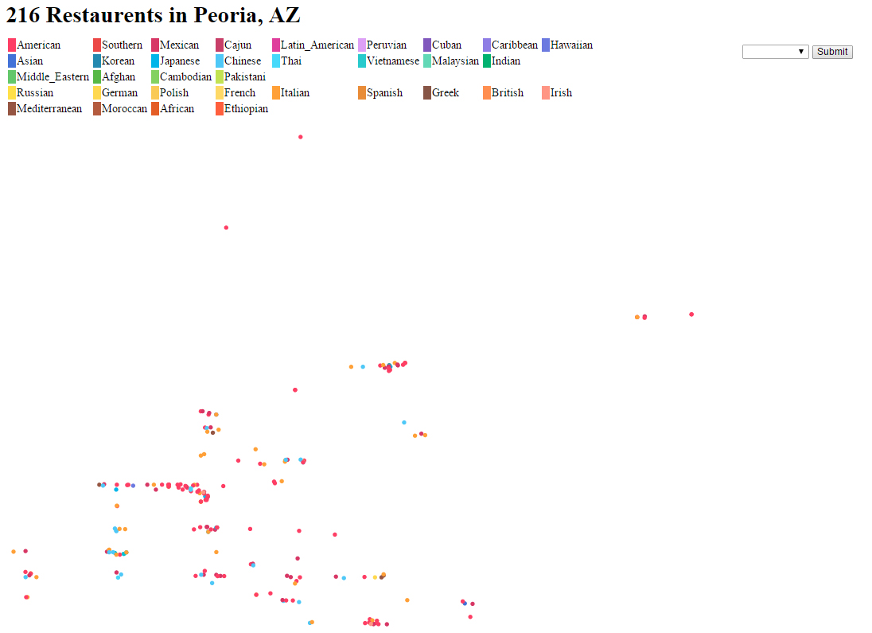

Figure 8 - Peoria screen shot

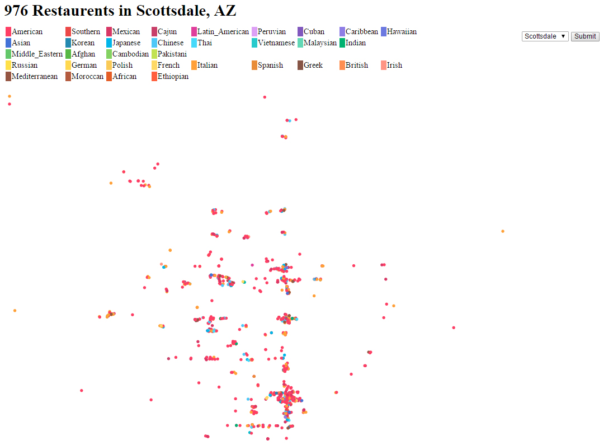

Figure 9 - Scottsdale screen shot

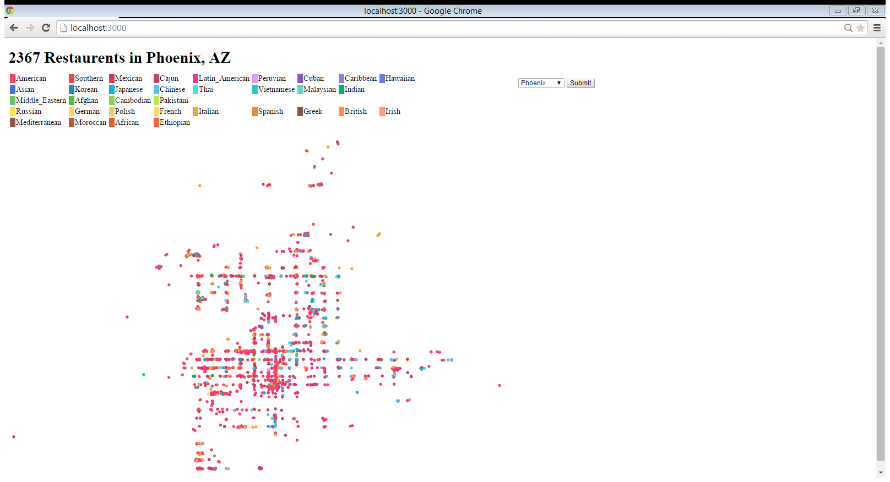

Figure 10 - Phoenix screenshot